

Model Prescription Monitoring Program Act

August 2026

Mission Statement of the

National Association of Boards of Pharmacy

NABP Mission Statement
The National Association of Boards of Pharmacy (NABP) is the independent, international, and impartial Association that assists its member boards in protecting the public health.
Vision Statement
Innovating and collaborating today for a safer public health tomorrow.

NABP Member Boards of Pharmacy
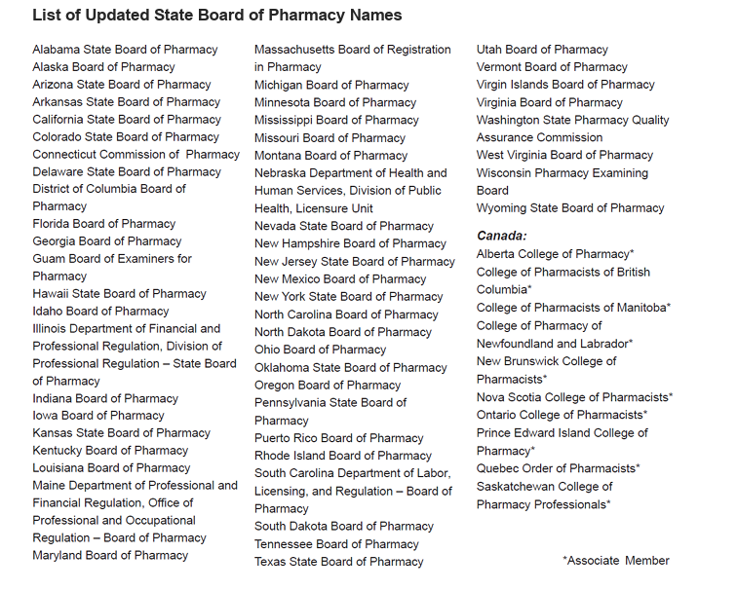

Model Prescription Monitoring Program Act

August 2026

Published by:
National Association of Boards of Pharmacy
1600 Feehanville Drive
Mount Prospect, IL 60056
847/391-4406
Lemrey “Al” Carter, PharmD, MS, RPh
Executive Director/Secretary

© 2026, National Association of Boards of Pharmacy. All rights reserved.
No part of this publication may be reproduced in any manner without the written permission of the executive director/secretary of the National Association of Boards of Pharmacy. Violation of the copyright will lead to prosecution under federal copyright laws.

Model Prescription Monitoring Program Act 5
Section 1. Short Title. 5
Section 2. Legislative Findings. 5
Section 3. Purpose. 5
Section 4. Definitions. 5
Section 5. Establishment of a Prescription Monitoring Program. 6
Section 6. Reporting of Prescription Monitoring Program Information. 6
Section 7. Access to Prescription Monitoring Program Information/Confidentiality. 7
Section 8. Interoperability. 9
Section 9. Unlawful Acts and Penalties. 9
Section 10. Evaluation, Data Analysis, and Reporting. 9
Section 11. Rules. 10
Section 12. Severability. 10
Section 13. Effective Date. 10

Model Prescription Monitoring Program Act

Section 1. Short Title.
This Act shall be known and may be cited as the Model Prescription Monitoring Program Act.

Section 2. Legislative Findings.
[Insert state-appropriate mission/purposes.]

Section 3. Purpose.
[Insert state-appropriate mission/purposes.]

Section 4. Definitions.
For the purposes of this Act:
- “Dispenser” means a person authorized in this state to dispense to the ultimate user a substance monitored by the prescription monitoring program (PMP) but does not include a licensed hospital or institutional facility pharmacy that dispenses such substances for the purposes of inpatient care.
- “Drug of concern” means any prescription or over-the-counter drug deemed by the state to demonstrate a potential for abuse and is not currently scheduled as a controlled substance by state or federal law.
- “Electronic health information systems” means an electronic data intermediary, gateway, or hub that facilitates secure delivery of electronic health information to practitioners or dispensers, including the following:
  - health information exchanges;
  - health information networks;
  - pharmacy software systems;
  - electronic medical (health) record software applications; or
  - electronic prescribing software applications.
- “Interoperability” means the sharing of PMP information with another PMP, or the integration of PMP information into the electronic health information systems.
- “Prescription monitoring program information” means information submitted to and maintained by the PMP.
- “Prescription monitoring program” means a program established under Section 5 of this Act.

Section 5. Establishment of a Prescription Monitoring Program.
- The board of pharmacy shall establish and maintain an electronic system for monitoring all federal controlled substances in Schedules II through V, state-specified controlled substances in Schedules II through V, and state-specified drugs of concern dispensed in this state.
- The board of pharmacy may contract with a vendor to establish and maintain the electronic monitoring system pursuant to guidelines, which the board of pharmacy shall promulgate.
- The board of pharmacy shall promulgate rules or establish policy to include the following:
  - using the PMP to improve patient care and to facilitate the goal of reducing misuse, abuse, overdose, and addiction to and diversion of controlled substances and drugs of concern;
  - implementing security and safeguards necessary to ensure that information is released only to authorized individuals;
  - developing criteria for providing PMP information to a law enforcement agency;
  - developing criteria for providing PMP information to a licensing board or other state or federal agency charged with the regulation of prescribing, dispensing, or administering a controlled substance or drug of concern;
  - designing and implementing training, education, and/or instruction in the appropriate access to and use of the PMP;
  - adopting the American Society for Automation in Pharmacy technical standards for electronic reporting of PMP information; and
  - incorporating technological improvement to facilitate the interoperability of the PMP with other state PMPs and electronic health information systems and to facilitate prescribers’ and dispensers’ access to and use of the PMP.

Section 6. Reporting of Prescription Monitoring Program Information.
- Each dispenser shall submit to the PMP the following information:
  - identification number of the dispenser;
  - identification number of the prescriber;
  - patient first and last name, address, and telephone number;
  - patient date of birth;
  - identification of the drug by a National Drug Code number;
  - quantity dispensed;
  - number of days supplied;
  - number of refills ordered;
  - whether the drug was dispensed as a refill or as a new prescription;
  - date the prescription was dispensed;
  - prescription number;
  - date the prescription was issued by the prescriber;
  - method of payment for the prescription; and
  - such other information as may be required by state law or rule.
- Such information shall be submitted by electronic means by the end of the next business day after dispensing.
- A PMP may grant a waiver to the electronic submission of data requirement in unique circumstances.
- Each dispenser shall ensure that information reported to the PMP is correct and shall submit corrections when necessary.

Section 7. Access to Prescription Monitoring Program Information/Confidentiality.
- Except as indicated in paragraphs (2), (3), and (4) of this Section, PMP information submitted to the PMP shall be considered protected health information and not subject to public or open records laws.
- The board of pharmacy shall review the PMP information. If there is reasonable cause to believe a violation of law or rule (or breach of professional or occupational standards) may have occurred, the board shall notify the appropriate law enforcement, or professional or occupational licensing, certification, or regulatory agency or entity, and provide PMP information required for an investigation.
- The board of pharmacy may provide PMP information for public research, policy, or education purposes to the extent that all information has been de-identified and as permitted under state law or rule.
- The following persons may access the PMP information in the same or similar manner, and for the same or similar purposes, as those persons who are authorized to access similar protected health information under federal and state law and rules:
  - practitioners (or agents thereof) or dispensers (or agents thereof) who certify, under the procedures determined by the state, that the requested information is for the purpose of providing medical or pharmaceutical treatment or evaluating the need for such treatment to a bona fide current patient, or verifying PMP information for prescriptions issued by practitioners;
  - boards of pharmacy or vendors/contractors for the purpose of establishing and maintaining the PMP;
  - agents of other state licensing, certification, or regulatory agencies that license, certify, or regulate health care professionals authorized to prescribe, administer, and dispense controlled substances who certify, under the procedures determined by the state, that the requested information is related to an individual investigation or proceeding involving the unlawful diversion or misuse of a reportable substance, and such information would further the purpose of the investigation or assist in the proceeding;
  - agents of local, state, or federal law enforcement, narcotics control, licensure, disciplinary, or program authorities who certify, under the procedures determined by the state, that the requested information is related to an individual investigation or proceeding involving the unlawful diversion or misuse of a reportable substance, and such information would further the purpose of the investigation or assist in the proceeding;
  - entities that serve as sources of data impacting the identification and reporting of prescription drug injuries and deaths, such as, but not limited to, medical examiners or coroners (or agents thereof), to help address the prescription drug epidemic and improve patient care;
  - other appropriate entities; and
  - patients who certify, under the procedures determined by the state, that the requested information is for the purpose of obtaining and reviewing their own records.
- The board of pharmacy shall be immune from civil liability arising from inaccuracy of any of the information submitted to the PMP, pursuant to this Act.

Section 8. Interoperability.
- The board of pharmacy or applicable state agency shall execute a memorandum of understanding to participate in a single national hub capable of facilitating interoperability among PMPs and between PMPs and electronic health information systems.
- The board of pharmacy or applicable state agency shall ensure that access to PMP information by other state PMPs is done in compliance with the memorandum of understanding.
- The board of pharmacy or applicable state agency shall establish the technological connectivity and infrastructure to facilitate the secure delivery of PMP information to authorized users of PMPs through other states’ PMPs or electronic health information systems.
- Any electronic health information system that facilitates the integration of PMP information into a patient’s medical record shall:
  - verify the identity of the individual requesting the information;
  - verify the credentials of the individual requesting the information;
  - provide the board of pharmacy with an audit trail for each request; and
  - maintain the security and confidentiality of such information.

Section 9. Unlawful Acts and Penalties.
- A dispenser who knowingly fails to submit PMP information to the PMP, as required by this Act, shall be subject to [insert appropriate administrative, civil, or criminal penalty].
- A person who knowingly accesses or uses PMP information without authorization in violation of this Act shall be subject to [insert appropriate administrative, civil, or criminal penalty].
- A person authorized to have PMP information pursuant to this Act who knowingly discloses such information in violation of this Act shall be subject to [insert appropriate administrative, civil, or criminal penalty].
- A person authorized to have PMP information pursuant to this Act who uses such information in a manner or for a purpose in violation of this Act shall be subject to [insert appropriate administrative, civil, or criminal penalty].

Section 10. Evaluation, Data Analysis, and Reporting.
The board of pharmacy shall provide a report to the [insert appropriate state decision makers (eg, legislature)] on a periodic basis that contains, at a minimum, the following information:
  - costs associated with operating and maintaining the program;
  - funding sources;
  - prescribing and dispensing trends for each type of controlled substance;
  - total number of queries made to the program and the percentage of queries made through an integrated solution; and
  - any other information the board of pharmacy deems relevant to support public health policy.

Section 11. Rules.
The board of pharmacy shall promulgate rules necessary to implement the provisions of this Act.

Section 12. Severability.
If any provision of this Act or application thereof to any person or circumstance is held invalid, the invalidity does not affect other provisions or applications of the Act, which can be given effect without the invalid provisions or applications, and to this end, the provisions of this Act are severable.

Section 13. Effective Date.
This Act shall be effective on [insert specific date or reference to normal state method of determination of the effective date].

This reporting exception also applies to situations where a patient, who has been dispensed controlled substance drugs during a stay in an institutional facility, is allowed to retain any remaining drugs upon discharge.
Some states may assign this responsibility to an agency other than the board of pharmacy, such as the department of health.
Some states may consider including this information in rules rather than in statute.
It is recommended that boards of pharmacy consider using practitioner’s National Provider Identifier number for identification purposes when applicable. Consider using state license numbers for veterinarians.
For veterinary prescriptions, use the pet owner’s name, address, telephone number, gender, date of birth, and species code.
It is recommended that the date the prescription was dispensed be clarified to mean the date of delivery to the patient.
This Section is intended to allow boards of pharmacy to evaluate PMP information and determine appropriate information to provide to law enforcement entities. It is not intended to allow law enforcement officials open access to all data.
It is recommended that other appropriate entities include drug courts, district attorneys’ offices, addiction treatment professionals, or other similar entities, and only for the purpose of ensuring appropriate patient treatment, as opposed to efforts to search for information without knowledge of whether such information exists.
States are encouraged to utilize the model memorandum of understanding between NABP and [State] relating to its PMP.
It is contemplated that the acceptable use of PMP data is for a single instance review of a patient’s dispensing history and with consistency of information being delivered or presented.

