

Model Pharmacist Practice Act

August 2026

Mission Statement of the

National Association of Boards of Pharmacy

NABP Mission Statement
The National Association of Boards of Pharmacy (NABP) is the independent, international, and impartial Association that assists its member boards in protecting the public health.
Vision Statement
Innovating and collaborating today for a safer public health tomorrow.

NABP Member Boards of Pharmacy
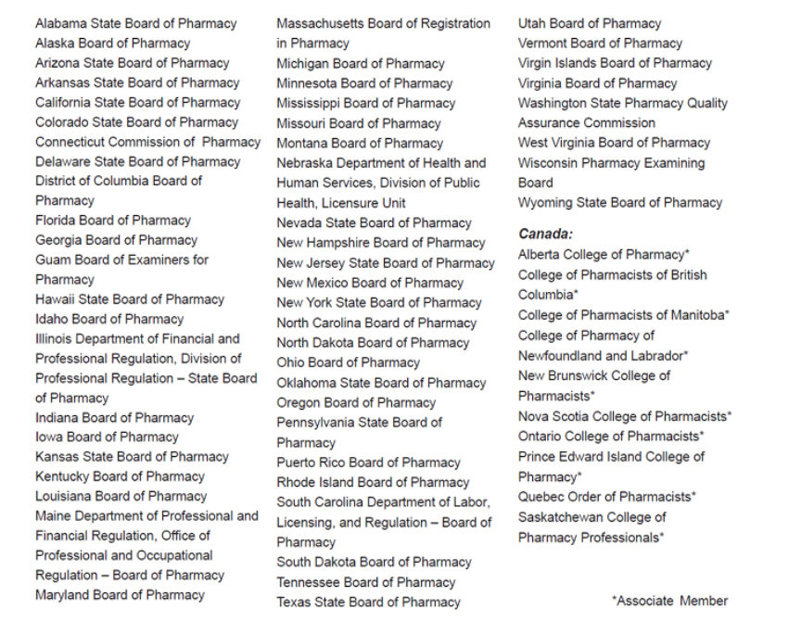

Model Pharmacist Practice Act

August 2026

Published by:
National Association of Boards of Pharmacy
1600 Feehanville Drive
Mount Prospect, IL 60056
847/391-4406
Lemrey “Al” Carter, PharmD, MS, RPh
Executive Director/Secretary

© 2026, National Association of Boards of Pharmacy. All rights reserved.
No part of this publication may be reproduced in any manner without the written permission of the executive director/secretary of the National Association of Boards of Pharmacy. Violation of the copyright will lead to prosecution under federal copyright laws.

Model Pharmacist Practice Act 5
Article I. Title, Purpose, and Definitions 5
Section 101. Title. 5
Section 102. Legislative Declaration. 5
Section 103. Definitions. 5
Article II. Professional Practice Standards 6
Section 201. General Approach to Pharmacist Practice. 6
Section 202. Practice Innovation. 6
Section 203. Pharmacist Prescribing Authority. 6
Article III. Delegation and Personnel 7
Section 301. Delegation of Functions. 7
Article IV. Discipline and Accountability 7
Section 401. Grounds for Discipline. 7
Section 402. Waiver Authority. 7

Model Pharmacist Practice Act

Article I. Title, Purpose, and Definitions
Section 101. Title.
This Act shall be known as the Model Pharmacist Practice Act.

Section 102. Legislative Declaration.
The practice of pharmacy is declared a professional health care practice affecting the public health, safety, and welfare, and is subject to regulation in the public interest. To ensure patient access to clinical services and practice innovation, this state adopts a standard of care approach to regulating pharmacists’ clinical and non-dispensing practices, allowing a flexible framework for practice expansion over time.

Section 103. Definitions.
“Dispense” or “dispensing” means the interpretation, evaluation, and implementation of a prescription drug order, including the preparation, final verification, and delivery of a drug or device to a patient or patient’s agent in a suitable container appropriately labeled for subsequent administration to, or use by, a patient.
“Pharmacist care services” mean services intended to achieve patient outcomes related to the treatment or prevention of disease, elimination or reduction of symptoms, and promotion of health and wellness. Pharmacist care services include, but are not limited to, the following:
- drug utilization review;
- medication adherence monitoring service;
- prescribing, administering, and dispensing drugs or devices;
- medication therapy management;
- reviewing, selecting, and developing formularies and/or practice guidelines;
- performing drug product selection, substitution, therapeutic interchange, prescription adaptation, or continuation of therapy;
- prescribing medications consistent with clinical education, training, or experience; and
- ordering, interpreting laboratory tests, and performing Clinical Laboratory Improvement Amendments-waived lab tests.

The “practice of pharmacy” means, but is not limited to, the following:
- interpreting, evaluating, compounding, dispensing, and/or administering medical orders;
- providing patient counseling and education;
- assessing the patient for the purposes of prescribing drugs and devices;
- initiating and/or providing pharmacist care services;
- using continuous quality improvement programs, emerging technologies, and competency-based education to improve patient safety and the quality of services provided; and
- engaging in collaborative pharmacy practice.

“Prescription adaptation” means an act by which a pharmacist uses their clinical judgment to modify or substitute a prescription issued by a practitioner to better suit the patient’s specific needs, improve safety, or ensure the therapy is effective and cost-efficient for the patient.
“Standard of care” means the degree of care a prudent and reasonable licensee or registrant with similar education, training, and experience would exercise under similar circumstances.

Article II. Professional Practice Standards

Section 201. General Approach to Pharmacist Practice.
To evaluate whether a specific action is within the practice of pharmacy, or whether an action can be delegated to other individuals, a licensee or registrant shall independently determine whether:
- The action is expressly prohibited by this Act, the Pharmacy Practice Act, the Uniform Controlled Substances Act, rules of the board, or any other applicable state or federal laws.
- The action is consistent with the individual’s education, training, and experience.
- Performance of the action is within the accepted standard of care that would be provided in a similar setting by a reasonable and prudent individual with similar education, training, and experience.

Section 202. Practice Innovation.
The board shall not require express permission for the implementation of new technology or clinical services that are not otherwise prohibited by law, provided that the services are performed in accordance with the standard of care.

Section 203. Pharmacist Prescribing Authority.
A pharmacist may independently prescribe drugs and devices if such pharmacist:
- Obtains adequate information about the patient’s health status to make appropriate decisions based on the standard of care and best available evidence
- Maintains adequate documentation, which shall become part of the patient’s permanent record and be readily available to other health care professionals who are providing care to that patient and who are authorized to receive it

Article III. Delegation and Personnel

Section 301. Delegation of Functions.
A pharmacist may delegate any task to any individual under their supervision, provided the pharmacist determines the delegate has the requisite education, training, and experience to perform the task safely and within the standard of care.

Article IV. Discipline and Accountability

Section 401. Grounds for Discipline.
The board may discipline a licensee or registrant for unprofessional conduct, which includes the following:
- Standard of Care Violations: Actions or omissions that fail to meet the standard of care provided by other qualified licensees or registrants in the same or similar setting
- Incapacity: A lack of fitness for professional practice due to incompetency or impairment that endangers the public
- Divergence From Professional Prudence: Engaging in conduct that substantially departs from the standards of care ordinarily exercised by a licensee or registrant, regardless of whether actual injury to a patient is established

Section 402. Waiver Authority.
The board is authorized to grant waivers from state rules or laws pertaining to the practice of pharmacy if the request is in the best interest of the public.

