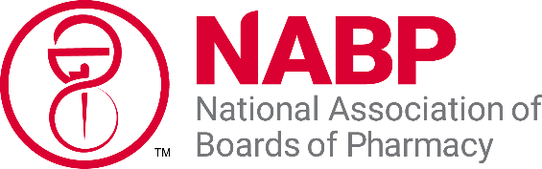
Submission of District Resolutions to NABP

Resolutions adopted at the National Association of Boards of Pharmacy (NABP) Annual Meeting influence the policy and activity of NABP in the coming year. The Committee on Resolutions consists of eight members, one from each district, and said member formally represents the district at the Committee on Resolutions meeting. We ask that the delegate (and if needed, alternate) designated at the district meeting serving on the Committee on Resolutions meeting be a current board member at the time of the Annual Meeting.

Article IV Section 6 of the NABP Constitution states:
- The Committee on Resolutions will meet during the Annual Meeting of the Association to give due consideration of resolutions submitted to the Association, check against duplication or contradiction with past resolutions or policy adopted by this Association, refer all resolutions concerning examination procedures not previously so referred by the Executive Director/Secretary to the Advisory Committee on Examinations for report before submitting same to the Association, and put resolutions in proper phraseology and form before submitting them to the Association. All resolutions shall be submitted to the Association for consideration, with a committee recommendation to “pass,” “not pass,” or “no recommendation.”
- Any active member board, District, or committee of the Association may submit resolutions to the Association. Except as otherwise provided in subparagraph (c) of this section, all resolutions submitted in writing to the Association at least twenty (20) days prior to the date of the Annual Meeting shall be presented at the Annual Meeting for consideration. Resolutions not presented within such time limitations may be presented during the Annual Meeting and will be considered for adoption by the Association upon the affirmative vote of three-fourths (3/4) of those active member boards present and constituting a quorum.

In order for each resolution from your district to retain its original intent throughout the review and revision process, please submit all substantive and Association-wide resolutions (those meant to be considered for adoption by the full NABP membership) in accordance with the NABP Constitution (Article IV, Section 6) utilizing this attached form. This form will also assist your district delegate to the Committee on Resolutions during the committee meeting.

We strongly encourage resolutions under consideration be submitted to the District Secretary/Treasurer and NABP at least 20 days prior to each of the respective district meetings in order to provide appropriate discussion at the district meeting. In order to avoid duplication or contradiction with past resolutions adopted by the Association, or to view examples of resolution language/format, we recommend visiting the Reports section of the NABP website to view past resolutions at:
https://nabp.pharmacy/publications-reports/reports/resolutions

Title of the Proposed Resolution: _______________________________________________

Provide brief background information on the proposed resolution.

What issue or need does this resolution attempt to address?

Is this actionable for NABP? ___ Yes ___ No

What is the desired outcome (ie, what specific action do you want NABP to achieve)?

Is this in NABP’s scope or sphere of influence? ___ Yes ___ No

Does this fit within the mission of NABP? ___ Yes ___ No
Mission Statement: NABP is the independent, international, and impartial association that assists its member boards and jurisdictions for the purpose of protecting the public health.

Proposed Resolution Language:
Proposed Resolution:

Indicate the individual who will serve as the contact for the proposed resolution between the district meeting and the Committee on Resolutions meeting in May.

